AWS Architecture Documentation
AWS Architecture Flow document that captures high availability, observability, and automated deployment — exactly the way you outlined. I’ve structured it so you can drop it into design docs or presentations.

📘 AWS Architecture Documentation
🎯 Goals
- High Availability: Multi-AZ ALB + Auto Scaling EC2 instances in private subnets.
- Observability: CloudWatch metrics, logs, alarms, SNS notifications, CloudTrail auditing.
- Automated Deployment: GitHub Actions CI/CD pipeline integrated with AWS.

🔹 End-to-End Flow
- User request → Application URL (DNS).
- Internet-facing ALB in public subnets receives traffic.
- ALB forwards to EC2 instances in private subnets via target group health checks.
- EC2 instances run Python web app, publish logs/metrics to CloudWatch.
- CloudWatch alarms trigger SNS notifications for alerts.
- CloudTrail captures API activities → stored in S3 for auditing.
- GitHub Actions pipeline validates & deploys code updates into AWS environment.

📊 Visual Layers
1. Overall AWS Architecture
- Presentation Layer: ALB in public subnets.
- Application Layer: EC2 Auto Scaling Group in private subnets.
- Infrastructure Layer: VPC, IGW, Route Tables, Security Groups.
- Observability Layer: CloudWatch, SNS, CloudTrail, S3.
- CI/CD Layer: GitHub → GitHub Actions → AWS Deployments.

2. Request & Monitoring Path
- User → ALB → EC2 → Response.
- EC2 → CloudWatch → Alarm → SNS → Notification.

3. CI/CD Deployment Flow
- Developer commit → GitHub → GitHub Actions → Test → Deploy → AWS → ASG → ALB.

4. Network & Security Layer
- Internet → IGW → Public Route Table → ALB.
- ALB SG allows 80/443.
- EC2 SG allows app port from ALB SG.
- Private Route Table isolates EC2 instances.

5. AWS Service View
- Core Networking: VPC, IGW, Route Tables, Security Groups.
- Compute: EC2 + Auto Scaling Group.
- Load Balancing: ALB.
- Monitoring: CloudWatch, SNS.
- Auditing: CloudTrail + S3.
- CI/CD: GitHub Actions → AWS Deployments.

⚡ Best Practices
- Deploy ALB across multiple AZs for resilience.
- Use Auto Scaling Group with health checks for elasticity.
- Enable CloudWatch log retention + alarms tied to SNS.
- Configure CloudTrail with log file validation for security.
- Secure IAM roles with least privilege.
- Automate deployments via GitHub Actions → AWS CLI/Terraform.

👉 Harish, since you already love visual schematic diagrams, I can prepare a clean enterprise-grade architecture diagram image (with AWS official icons) that you can drop into documentation or presentations. Would you like me to generate that visual now?
Single VPC:

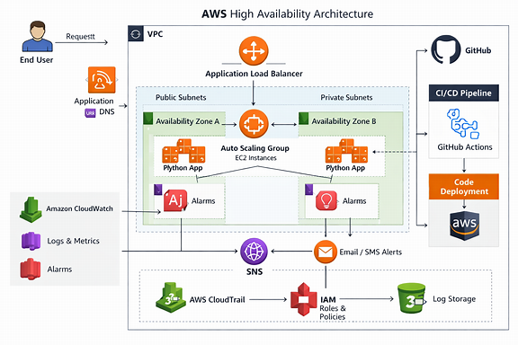
This diagram uses official AWS service icons and shows:
- Public subnets with ALB across multiple AZs.
- Private subnets with EC2 instances in an Auto Scaling Group.
- CloudWatch + SNS for observability and alerts.
- CloudTrail + S3 + IAM for auditing and security.
- GitHub Actions pipeline for automated deployments.
- GitHub Actions CI/CD pipeline for automated deployments.

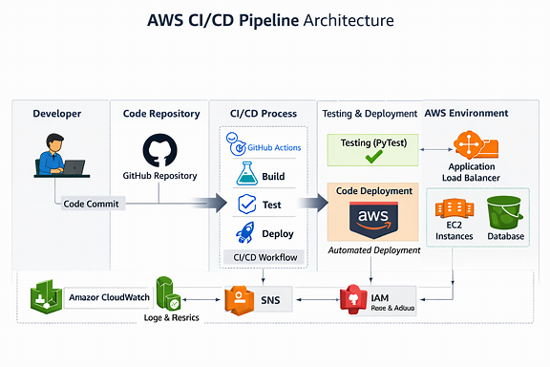
It illustrates:
- 👨‍💻 Developer Commit → GitHub Repository
- ⚙️ GitHub Actions Workflow → Build → Test → Deploy stages
- 🚀 Automated Deployment → AWS environment (ALB, EC2, Database)
- ✅ Continuous Integration & Delivery with PyTest validation and auto-scaling updates

Network-centric architecture visual
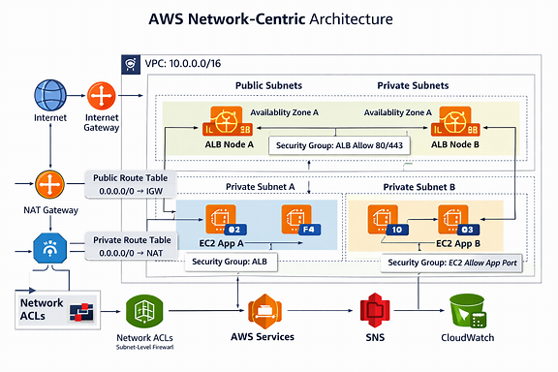

It shows:
- 🌐 Internet Gateway (IGW) and NAT Gateway for inbound/outbound traffic.
- 🧭 Public Route Table (0.0.0.0/0 → IGW) and Private Route Table (0.0.0.0/0 → NAT).
- 🏗️ Public Subnets hosting ALB nodes across Availability Zones.
- 🔒 Private Subnets running EC2 app instances with isolated access.
- 🧱 Security Groups and Network ACLs enforcing subnet-level firewall rules.
- 📡 Outbound access to AWS services like S3, RDS, and CloudWatch.

AWS Security-Focused Architecture:
It highlights:
- 🧩 IAM Roles & Policies enforcing least-privilege access across EC2, ALB, and CI/CD pipelines.
- 🔐 KMS Encryption securing S3 logs, CloudTrail data, and application secrets.
- 🧱 Security Groups & Network ACLs protecting ingress/egress at subnet and instance levels.
- 🕵️ CloudTrail + Config + GuardDuty for audit, compliance, and threat detection.
- 📡 SNS + CloudWatch Alarms for real-time security notifications.
- 🧮 GitHub Actions → IAM OIDC trust for secure CI/CD authentication without static credentials.

AWS Disaster-Recovery and Backup Architecture:
It illustrates:
- 🌍 Primary Region hosting production workloads (ALB, EC2, RDS, S3).
- 🔁 Secondary Region configured for disaster recovery with standby resources and cross-region replication.
- 🪣 S3 Cross-Region Replication for backups and static assets.
- 🧩 RDS Multi-AZ + Read Replica for database redundancy.
- 🧱 Route 53 Failover Routing automatically redirecting traffic to the DR region.
- 🧮 CloudWatch + SNS monitoring health and triggering DR automation.
- 🧰 Backup & Restore Layer using AWS Backup, EBS snapshots, and lifecycle policies.

Cost-optimization and scaling:
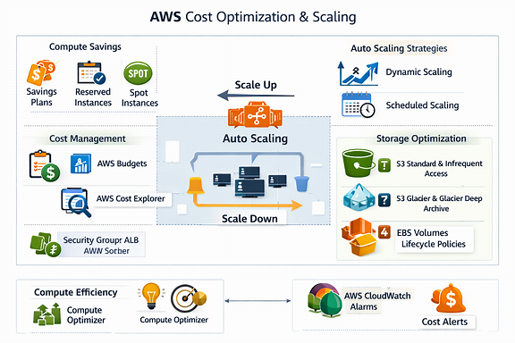

It captures:
- 🌍 Primary Region hosting production workloads (ALB, EC2, RDS, S3).
- 🔁 Secondary Region configured for disaster recovery with cross-region replication.
- 🪣 S3 Cross-Region Replication for backups and static assets.
- 🧩 RDS Multi-AZ + Read Replica for database redundancy.
- 🧮 Route 53 Failover Routing automatically redirecting traffic to the DR region.
- 🛡️ AWS Backup + EBS Snapshots for point-in-time recovery.
- 📡 CloudWatch + SNS monitoring health and triggering DR automation.

Combined master architecture map:
It brings together:
- 🌐 Network Layer — VPC, subnets, route tables, IGW, NAT, and security groups.
- 🏗️ Application Layer — ALB, Auto Scaling EC2 instances, and private compute zones.
- ⚙️ CI/CD Layer — GitHub Actions pipeline deploying code to AWS.
- 📊 Observability Layer — CloudWatch, SNS, and CloudTrail for monitoring and auditing.
- 🔐 Security Layer — IAM roles, policies, KMS encryption, and GuardDuty.
- 💾 Backup & DR Layer — S3 cross-region replication, RDS Multi-AZ, Route 53 failover.
- 💸 Cost Optimization Layer — Auto Scaling, Spot Instances, and lifecycle policies.

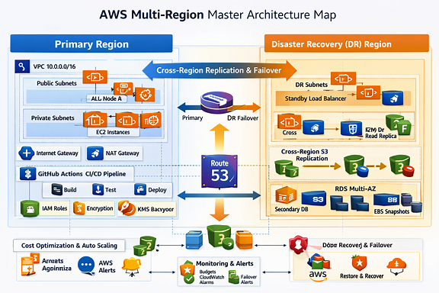
It features:
- 🌍 Primary Region (Blue Zone) for production workloads — ALB, EC2, RDS, CloudWatch, CI/CD pipeline.
- 🧡 Disaster Recovery Region (Orange Zone) for standby resources — DR subnets, RDS read replicas, S3 replication.
- 🔁 Cross-Region Replication & Failover Arrows connecting both regions through Route 53 failover routing.
- 🔐 Security & IAM Layer with KMS encryption, IAM roles, and GuardDuty monitoring.
- 🧩 CI/CD Integration via GitHub Actions deploying across regions.
- 💾 Backup & Recovery Layer with AWS Backup, EBS snapshots, and S3 archive.
- 💸 Cost Optimization & Auto Scaling ensuring efficiency across zones.

Multiple VPC:

